**Documentation of Version Control system**

|  |  |
| --- | --- |
| Group member name | Roll number |
| Rubesha Memon | 21sw072 |
| Anjli kumari | 21sw118 |
| Yogeeta Lohana | 21sw041 |
| Rizeen Yasin | 21sw147 |

We have documented the steps we have followed to use version control system for our website. Website documentation is also provided in a separate word file.

STEP 1: Committing home page code to central repository.

21sw072 worked on the homepage to give an initial base to the website on her local machine then pushed the changes to the central repository on github.

E:\5th semester\SCD\Notes\initial.PNG

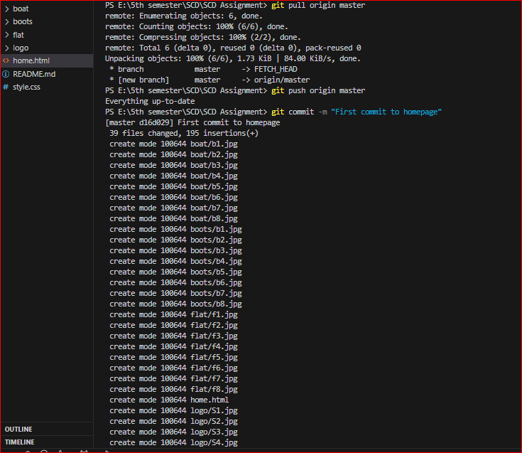

STEP 2: Making branches for each feature of the website

We divided the tasks as Pages on the website. Each group member getting a separate branch access to work on and later merging the page to the master branch.

* 21sw072: Homepage(master) and BootShoePageBranch
* 21sw118: landingPage Branch and Sneakers display page branch
* 21sw041: Boat Shoe display page branch
* 21sw147: Flat shoe display page branch

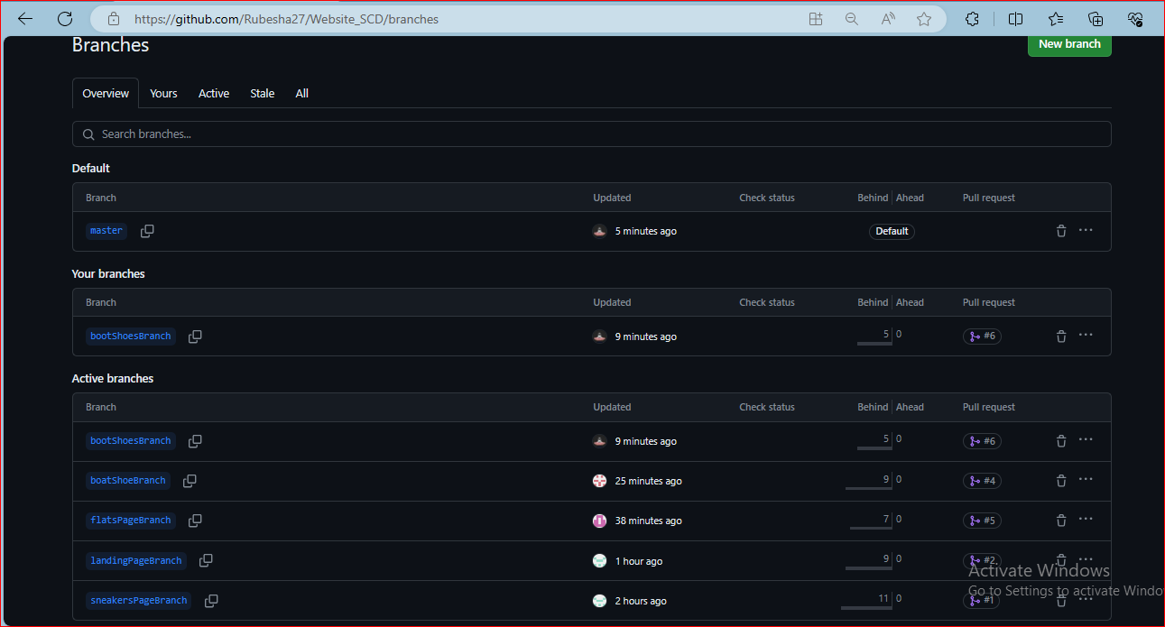

STEP3: Merging to the master branch

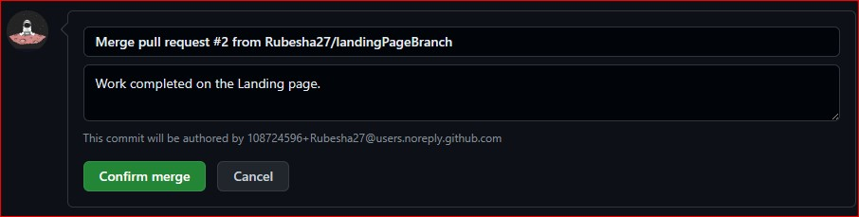

STEP 4: Changes made to style.css file in the bootShoeBranch

* Border radius change
* Hover background color changed
* Text color changed of .menu a hover{}

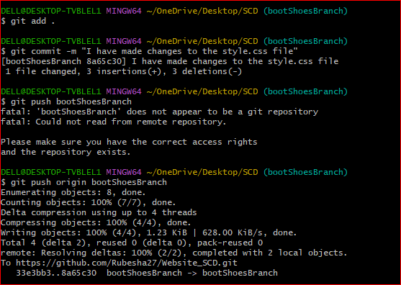

We made changes to style.css file in bootShoeBranch to see **if any conflicts arise.**

Resolving conflicts:

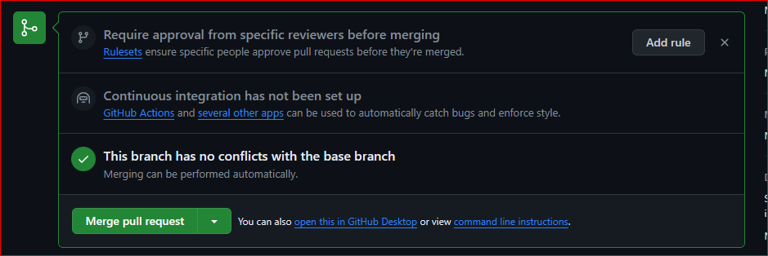

**Here the conflict arised with README file.**

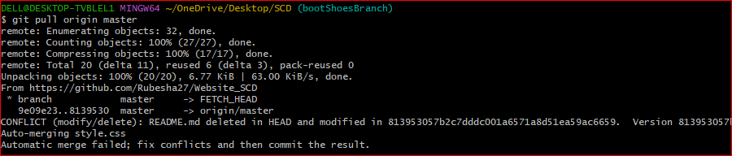

.gitignore file

We have added readme file to .gitignore folder because we don’t want it to be tracked.



UNDO COMMIT:

The command we used to undo last commit

**git reset --soft HEAD~1**

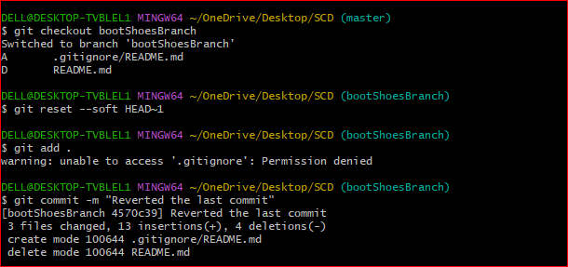

Git stashing

We made a new branch called documentation branch. And used git stash command to resume the work on the branch later.

